HDOC DAY-49
NAME-PRIYADARSHNA
SAPID-590032928
BATCH-15
Aim
Write a C program to find the pivot integer using a function and pointers.
Algorithm
- Start.
- Input a positive integer n.
- Pass its address to pivot_integer(&n).
- Calculate sum = n*(n+1)/2.
- Check whether i*i == sum for each integer from 1 to n.
- Print the pivot integer if found; otherwise print -1.
- Stop.

>C PROGRAM:
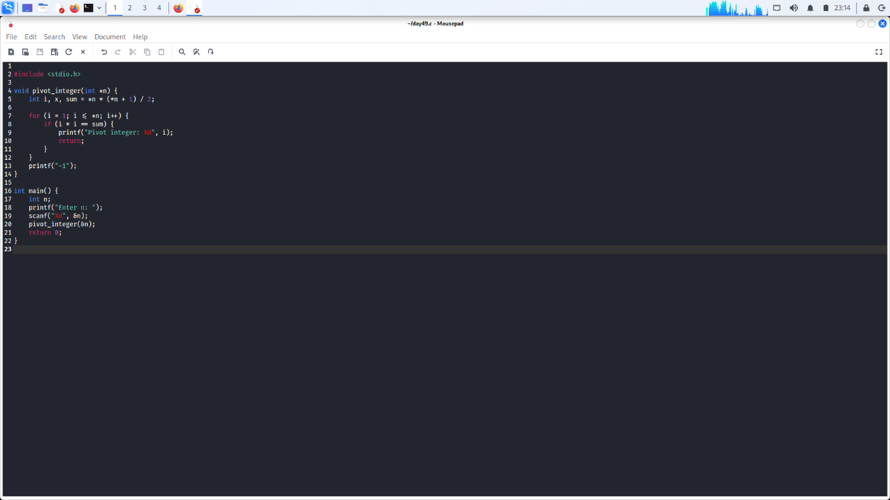

>OUTOUT:
